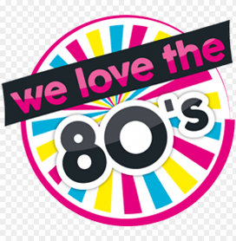
80’s Party -- 80’s Music
THURSDAY – Sept 21, 2023
5 PM

Dress 80’s If You Like

Dinner : Spaghetti, Salad, Bread,
Drink & Desert - $6.00

River Oaks Event Center
5300 Blackstone Dr
River Oaks, Texas 76114
www.riveroakscommunitycenter.com

